Website Building for Predicting Residential Property Prices Using Supervised Learning
Artificial Intelligence Coursework
Sushma Reena Paul Raj

1.1 Abstract
This research aims to design a web-based platform that foresees the values of residential properties based on supervised learning. The platform makes its evaluation in the following aspects such as the area of the house, facilities, and market trends with the help of machine learning algorithms and a lot of datasets. A higher degree of transparency is facilitated by users entering property data to get predictions and insight immediately. Updates often mean a higher flexibility in keeping up with the changing market. Embracing users from real estate experts, buyers and sellers, the app is a perfect platform for making sound choices and innovation in the real estate sector by using modern-day machine learning for property valuation.

1.2 Introduction
In the fast-changing world of real estate, correctly measuring housing prices is a hard task, because of the many factors that play a role and the complexity of market conditions. This challenge is tackled by a web-based tool that utilises the power of supervised learning to predict residential property prices. Supervised learning being one of the key elements of machine learning turns out to be very useful in distinguishing complex patterns among diverse datasets and thus forms a good groundwork for a precise property valuation [17]. The platform utilizes sophisticated algorithms like linear regression, XGB regressor, and Random Forest regressor, to increase the precision and credibility in predicting housing values.
The project involves a stepwise procedure, which includes data collection, feature analysis, model training, and evaluation, and ends up with the website development and application. This platform allows users to put in precise information on properties having immediate response and outlook. The ultimate objective is to create a platform for stakeholders in the property market which will aid them in making rational decisions with the help of data and transparent valuations. Building up cutting-edge algorithms and a user-friendly interface, our project aims to overcome the obstacles of the real estate market and provide a solution which is both precise and informed for property valuation.

1.3 Literature Review
Nowadays Residential valuation is a vital task when it relates to marketing research and real estate’s proper evaluation. Thanks to technological innovations and numerous records, managed to study applications in this field have also increased their popularity. Thus, the purpose of this literature evaluation is to investigate a range of strategies and approaches employed in the utilization of supervised learning techniques for cost prediction in residential properties. Take a look alerts readers with knowledge of the subject from integrating results obtained during previous research.
Evolution in residential property price prediction models has significantly incorporated approaches to enhance accuracy, comprehensibility and usefulness. A groundbreaking study, by McCluskey et al. (2013) compared methods, artificial neural networks (ANNs) and conventional linear hedonic pricing models to estimate property values. The results highlighted the advantages of using regression in terms of accuracy, reliability and model understanding. While ANNs have capabilities their complex design can pose challenges in real-world scenarios. On the other hand, conventional linear hedonic pricing models are a choice due to their affordability and ease of application. Striking a balance, between transparency and performance the weighted regression strategy emerged as the compromise.
In a study, Hong et al. (2020) explore the world of Random Forest (RF) methodology. Compare its effectiveness, with traditional hedonic pricing models in predicting house prices. By analyzing transaction data from apartments in Gangnam, South Korea the researchers discovered that the RF method performs better than models achieving accuracy and significantly lower average percentage deviation. This research highlights the potential of using RF as a tool to capture the complexities and non-linearities that exist in housing markets.
Specialized modelling is reflected in the work of Deboosere et al. (2019) where they focus on hedonic regression modelling concerning Airbnb listing prices reported against New York City neighbourhoods. For example, their research shows that locational factors and neighbourhood effects impact significantly on the average price per night as well as monthly revenue. What is even more remarkable, the professionalization of the short-term rental market comes out as one of those factors influencing revenue distribution. Diversifying, Fu et al. (2019) focus on the effect of scenery near residential houses in Beijing and Shanghai to explain how greenery or sky-perceptive elements can raise housing prices.
Further enriching the terrain, Khan et al. (2021) shed light on an ensemble model which uses Random Forest RF and Recurrent Neural Networks RNN for price prediction of properties in Brazil. Their study highlights the potential benefit of improving datasets and incorporating a range of machine-learning procedures to aid forecasting.
Spatial factors also come into focus as Crosby et al. (2018) propose a method for enhancing house price prediction through the incorporation of road distance and travel time. This study accentuates the importance of considering spatial features in property price prediction models, a consideration that could be extrapolated to enhance accuracy on real estate websites.
With these studies synthesized, one can glean a rich array of methodologies ranging from robust yet rudimentary quantitative and qualitative approaches to more nuanced exploration contributing detailed observations into the intricate field that residential property price prediction may be. Geographically oriented techniques, and methods involving machine learning and individual models provide various potentials to examine further; additionally, ensemble approaches grace predictions with improved accuracy and interpretability. The dynamism underlying these studies indicates a promising future for further research, emphasizing the still unresolved aspects of real estate markets as to their nature.

1.4 Data Description
The chosen data for this project is the Housing Prices dataset taken from Kaggle Datasets [9]. The dataset consists of 545 entries and 13 variables. This dataset consists of 12 input variables and 1 output variable, where input talks about the area of a house, the number of bedrooms in a house, the number of bathrooms in a house, the number of stories in a house, whether the house connected to the main road, Whether the house has a guest room, Whether the house has a basement, Whether the house has a hot water heater, Whether the house has an air conditioner, the number of parking in the house, whether the house is in the preferred area and the furnishing status of the house. The target variable is the price of the house.

1.5 Methodology
This section contains the outline of the steps involved in the building of a website, which is represented in the following Flow chart 1.
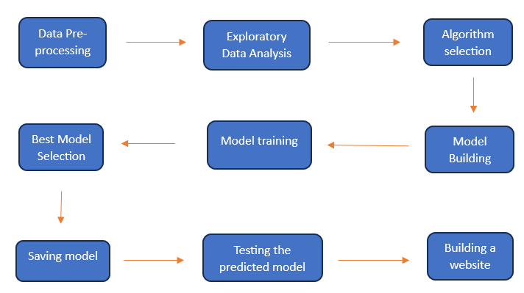
Flow Chart 1: Methodology

1.5.1 Data Pre-processing
Data Pre-processing is the process of preparing the raw data in a way that can be used by machine learning algorithms to build the best model that gives the optimal solution for the problem we have chosen to solve [18]. It is most important for the machine learning algorithm because it reduces its complexities. It involves several steps like handling null values, removing outliers etc., that can be chosen based on the nature of the dataset.
- After importing the data and checking for defects in the datasets, no duplicates or null values were found in the data.
- After checking for outliers in the data which affect statistical analysis and model performance, using boxplots by importing Python libraries matplotlib and seaborn, it was found that the feature ‘price’ contained outliers. Those outliers were treated by capping them using the Interquartile Range [7][12].
- The dataset contained many categorical variables namely ‘mainroad’, ‘guestroom’, ‘basement’, ‘hotwaterheating’, ‘airconditioning’. Those features were normalized using LabelEncoder achieved using a library called Scikit learn. It was done to make the process analysis easier for the machine learning algorithms [13].

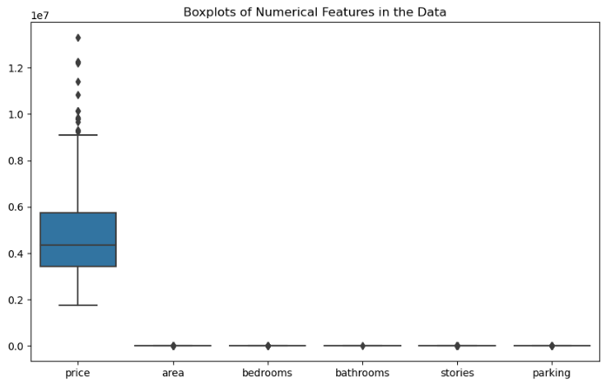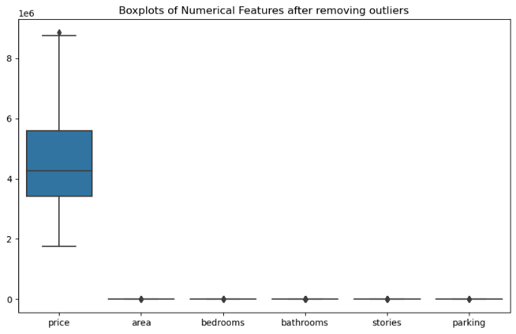
Plot 1: Before removing outliers
Plot 2: After removing outliers

1.5.2 Exploratory Data Analysis
Exploratory data Analysis contributes a major part to understanding the data and analyzing the relationship between the target variable and input variable. Some visualization has been done for this project too between ‘price’ and other input features. The following are the plots and inferences taken from the plots.

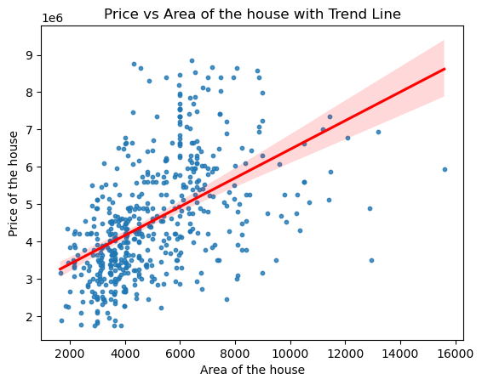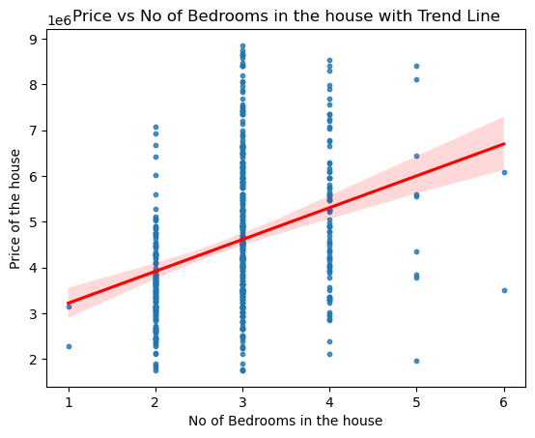
Plot 2
Plot 1

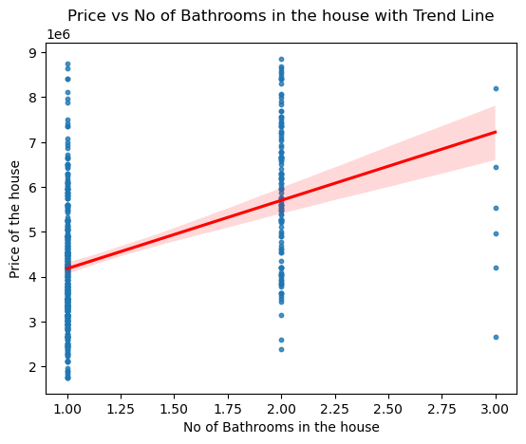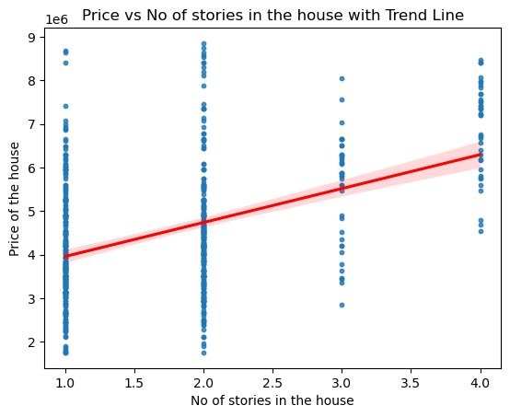
Plot 4
Plot 3
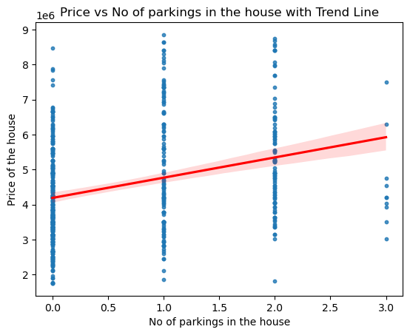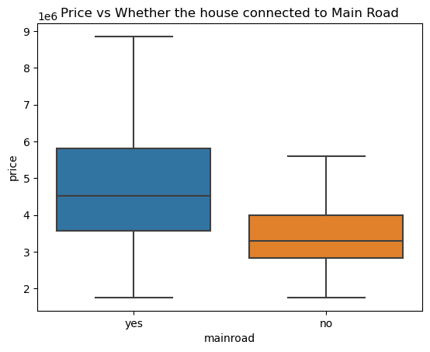
Plot 6
Plot 5
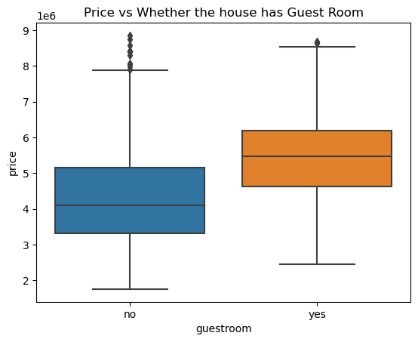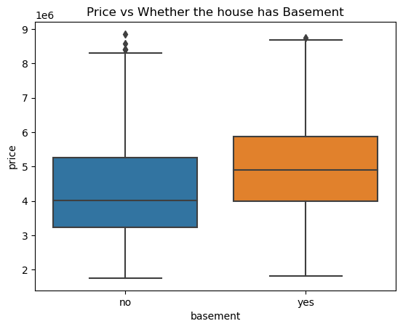
Plot 8
Plot 7
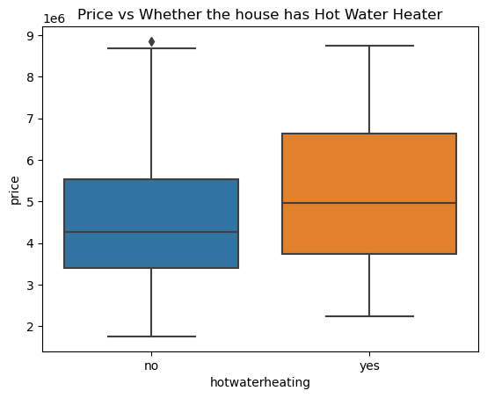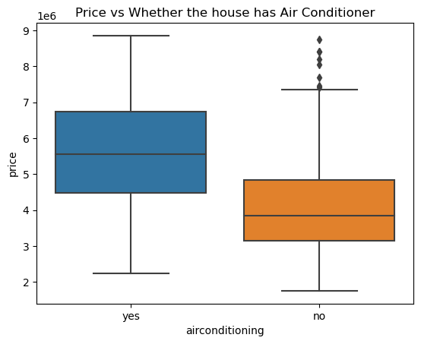
Plot 10
Plot 9
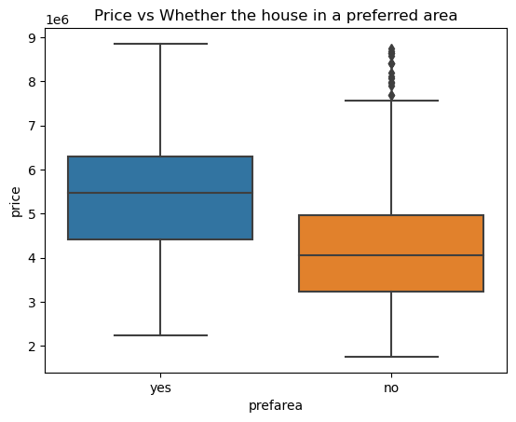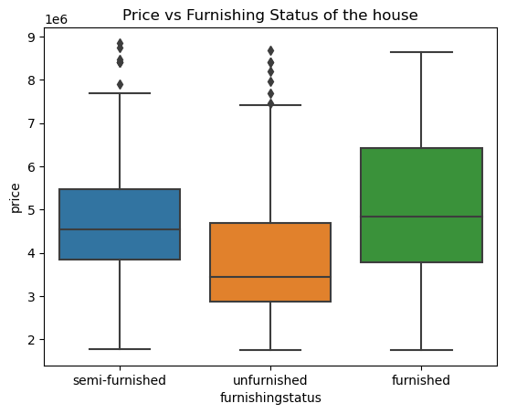
Plot 12
Plot 11

The above bivariate scatter plots imply that as the area of the house, number of bedrooms bathrooms, stories are parking increases, the price of the house also increases (from Plot 1,2,3,4 and 5). All these features are in a positive linear relationship with the price of the house. By taking the inference from the bivariate boxplots, it is understood that the houses connected to the main road, having guest room, contain basement, having hot water heater and air conditioner, located in the preferred area and in furnished state are having the high price (from Plot 6,7,8,9,10,11 and 12).
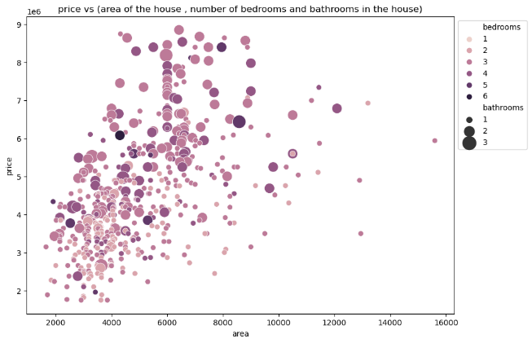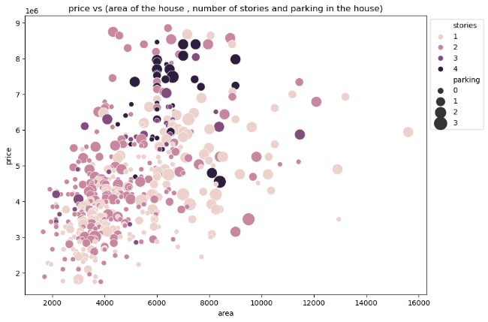
Plot 14
Plot 13
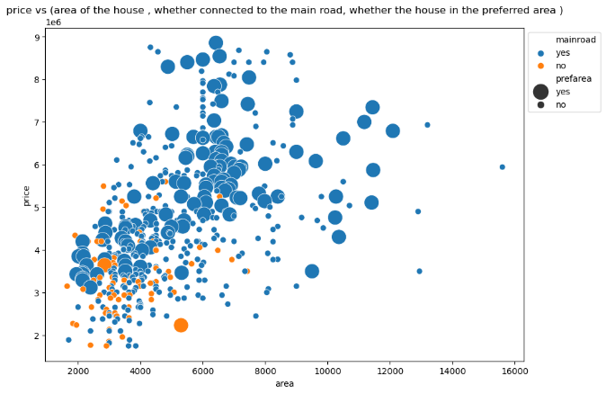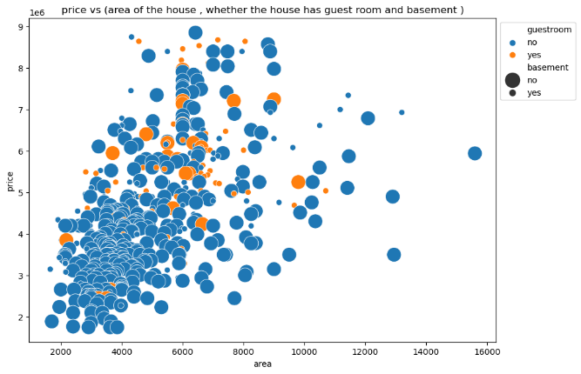
Plot 16
Plot 15
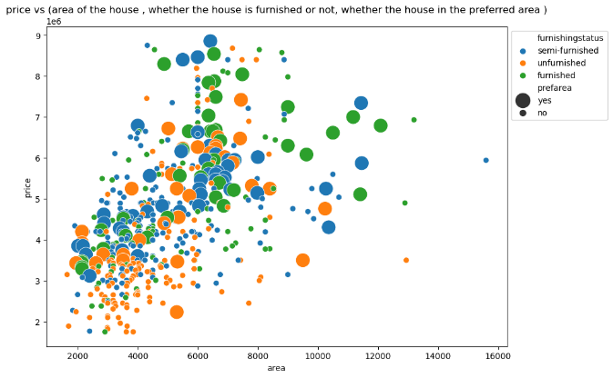
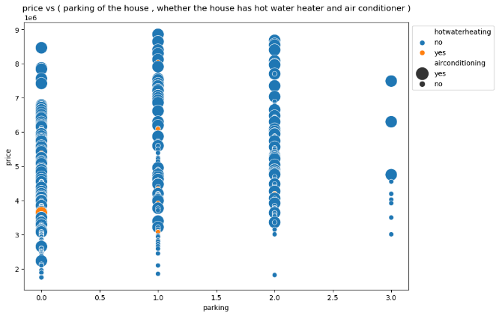

Plot 17
Plot 18

From the above multivariate scatter plots, it is inferred that houses having a large number of areas with a greater number of bedrooms and bathroom, having a large number of areas with a greater number of stories and parking, having large number of areas connected to main road and located in the preferred area, having large number of areas with guest room and basement, having parking with hot water heater and air conditioner, having large number of areas in furnished state and in preferred area have high price.

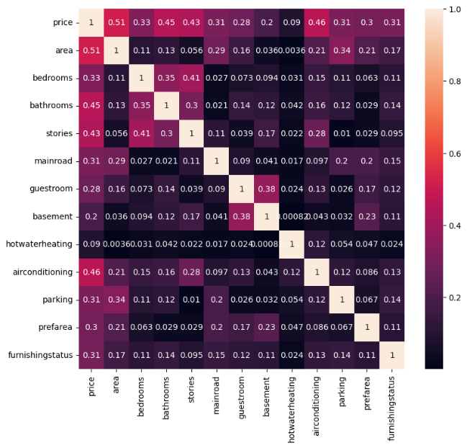
Heatmap 1

The above heat map shows that the correlation between features basement and hot water heater and price are weaker than the correlation with other features. It also helped us to do the feature selection where we can remove the weaker features to reduce the complexity of the model [21].

1.5.3 Algorithm Selection
Based on the above analysis and the nature of the dataset, algorithm selection took place which helped the model building. As all the features in the datasets are continuous and the problem is to predict the price of a house which is a quantity, Regression was chosen [6]. Some of the best-performing regression algorithms were selected. They are as follows,

1.5.3.1 Linear Regression
Linear is a statistical method used for modelling the relationship between a dependent variable and one or more independent variables by fitting a linear equation to the observed data. The linear equation is
$$Y=β0​+β1​X1​+β2​X2​+…+βn​Xn​+ε$$
The goal of linear regression is to find the values of the coefficients $(β0,β1, …., βn)$ that minimize the sum differences between the predicted and actual values of the dependent variables. It is widely used for predicting and understanding the relationship between variables [4].
1.5.3.2 Random Forest Regression
Random Forest Regression is doing regression using the ensemble learning technique. To provide a prediction that is more accurate than one from a single model, the ensemble learning method integrates predictions from several machine learning algorithms. The steps it follows are picking a random k training data point, building a decision tree, choosing the number of trees created by picking and building steps and predicting the value of y for those data points [2].
1.5.3.3 XGBoost Regression
XGBoost Regression also belongs to ensemble learning, especially for gradient boosting framework. By iteratively merging the predictions of several different models, frequently decision trees, XGBoost creates a predictive model. For the algorithm to function, weak learners are gradually added to the ensemble, with each new learner concentrating on fixing the mistakes caused by the previous ones. Throughout training, it minimizes a predetermined loss function by using an optimization approach called gradient descent [8].
1.5.4 Model Building and Evaluation
The following are the steps followed in building the model and evaluating the model.
- Importing required libraries for splitting the dataset, training the dataset using selected algorithms, tuning the hyperparameters used for each algorithm and predicting and evaluating the model using Scikit Learn, a Python library used for building various machine learning models [16].
- Splitting the dataset using ‘train_test_split’ a class in Scikit Learn library into 80% of training and 20% of testing data, where the weakly correlated features are dropped.
- Defining the selected algorithms with the required hyperparameters with values to be tuned.
- Tuning the hyperparameters using ‘RandomizedSearchCV’ a class in the Scikit Learn library.
- Fitting the training dataset in each of the selected algorithms for training the dataset to find the best hyperparameters.
- Predicting the test dataset using the trained model
- Calculating the evaluation metrics best score which gives the average performance of the model using cross-validation, R-squared and mean squared error for each of the algorithms to find the best model.
- Selecting the best model by checking which model has a high best score [5]. Table 1 shows the stored best score, R-squared and mean squared error for respective algorithms. From the table, it is found that the model created by using the XGBoost Algorithm is performing well with the best score of 0.631.
- Defining the XGBoost Regressor model with specified best parameters in Table 1 and again doing the steps from fitting to calculating. But this calculating testing score, R-squared and MSE values. After calculation we got the result as the testing score is 71.19, the R-squared value is 0.712 and the MSE value is 632723209589.171
- Saving the best model as a pickle file named xgb_model.txt
- Visualizing the performance using variance table (Table 2)
- Predicting using the saved model by giving a new inputs
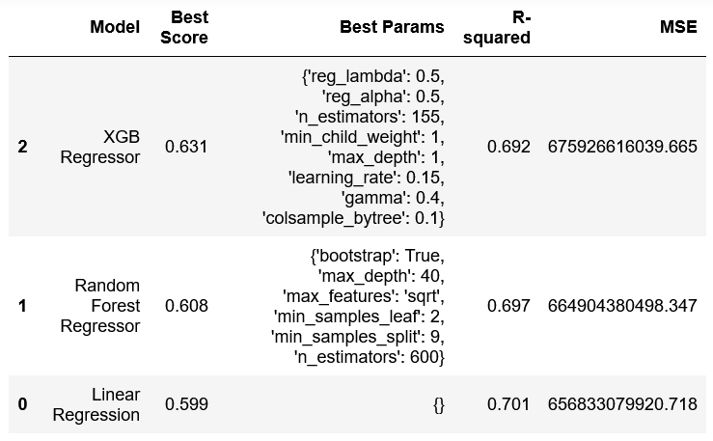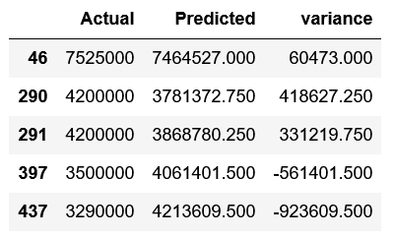
table 2
table 1

1.5.5 Web Building and Predicting Prices
The web application is built using a Python framework called Flask. One common term for Flask is "micro-framework." The main goal of its design is to maintain the application's scalability and simplicity. To provide such features to the application, Flask supports extensions in place of an abstraction layer [19]. After loading the saved model and running the code, it gave a link (http://127.0.0.1:5000/) to initiate access to the web. The web will allow users to give input and get predicted Price of the house. The following are the browsing and predicting tab of the web,
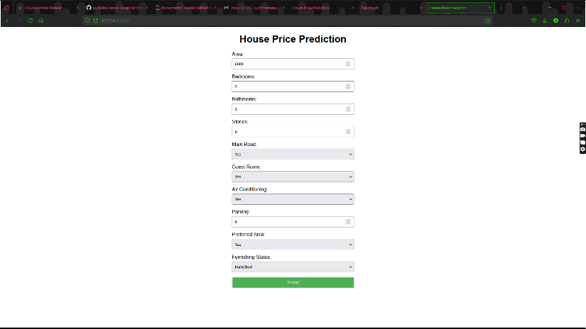
Browsing tab

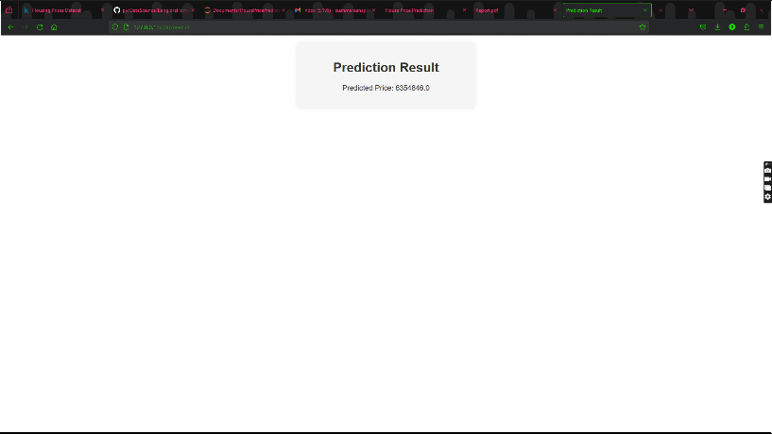
Predicting tab

1.6 Conclusion
The project succeeded in building a web-based platform that it used to predict the prices of residential properties through machine learning. The XGBoost Regressor stood out as the best-performing algorithm after the Housing Prices dataset was thoroughly cleaned and the relevant features selection was made with the best performance score of 71.19. The friendly Flask-based web application predicts property prices through the machine learning model that has been trained. The project supports informed and data-driven property valuation and the consequent influence on the real estate sector. Advancements and frequent updates in the future will ensure that the platform continues to be a determinant of transformation in the property valuation processes and information generation for informed decision-making in the real estate market characterized by dynamism.
1.7 Future Scope
The future scope involves expanding the dataset, analyzing more features, and incorporating advanced methods for enhanced prediction accuracy [14]. Constant model updates reflecting the real-time market trends, intuitive interactive features and geographical expansion will heighten the platform’s utility. Mobile application development with integration of user feedback ensures a continuous innovation process and user engagement.

1.8 Reference
[1]Anam-Nawaz Khan, Naeem Iqbal, Atif Rizwan, Rashid Ahmad, & Do-Hyeun Kim. (2021). “An Ensemble Energy Consumption Forecasting Model Based on Spatial-Temporal Clustering Analysis in Residential Buildings”. Energies, 14(11), 3020.
[2]Chaya (2020). “Random Forest Regression”, Medium. Available at: https://levelup.gitconnected.com/random-forest-regression-209c0f354c84.
[3]Fu X, Jia T, Zhang X, Li S, Zhang Y (2019). “Do street-level scene perceptions affect housing prices in Chinese megacities? An analysis using open access datasets and deep learning”. PLoS ONE,14(5): e0217505.
[4]GfG (2024). “Linear Regression in Machine Learning”, GeeksforGeeks. Available at: https://www.geeksforgeeks.org/ml-linear-regression/.
[5]Ghosh, S. (2024). “The Ultimate Guide to Evaluation and Selection of Models in Machine Learning”, neptune.ai. Available at: https://neptune.ai/blog/ml-model-evaluation-and-selection.
[6]Goyal, C. (2023). “How to choose an appropriate Machine Learning Algorithm for Data Science Projects?”, Analytics Vidhya. Available at: https://www.analyticsvidhya.com/blog/2021/07/how-to-choose-an-appropriate-ml-algorithm-data-science-projects/.
[7]Gress, T.W., Denvir, J. and Shapiro, J.I. (2018). “Effect of removing outliers on statistical inference: Implications to interpretation of experimental data in Medical Research”, Marshall Journal of Medicine. Available at: https://www.ncbi.nlm.nih.gov/pmc/articles/PMC7485938/
[8]Guest_blog (2024). “XGBoost: Introduction to XGBoost Algorithm in Machine Learning”, Analytics Vidhya. Available at: https://www.analyticsvidhya.com/blog/2018/09/an-end-to-end-guide-to-understand-the-math-behind-xgboost/.
[9]H, M.Yasserh (2022). “Housing prices dataset”, Kaggle. Available at: https://www.kaggle.com/datasets/yasserh/housing-prices-dataset/data.
[10]Henry Crosby, Theo Damoulas, Alex Caton, Paul Davis, João Porto de Albuquerque & Stephen A. Jarvis (2018). “Road distance and travel time for an improved house price Kriging predictor”, Geo-spatial Information Science, 21:3, 185-194.
[11]Hong, Jengei., Choi, Heeyoul., & Kim, Woo-sung. (2020). “A house price valuation based on the random forest approach: the mass appraisal of residential property in South Korea”. International Journal of Strategic Property Management, 24(3), 140-152.
[12]Kumar, P. (2020). “How to Handle Outliers”, LinkedIn. Available at: https://www.linkedin.com/pulse/how-handle-outliers-piyush-kumar.
[13]Morris, S. (2022). “Data normalization: Definition, importance, and advantages”, coresignal. Available at: https://coresignal.com/blog/data-normalization/.
[14]Ray, S. (2024). “8 Ways to Improve Accuracy of Machine Learning Models”, Analytics Vidhya. Available at: https://www.analyticsvidhya.com/blog/2015/12/improve-machine-learning-results/.
[15]Robbin Deboosere, Danielle Jane Kerrigan, David Wachsmuth & Ahmed El-Geneidy (2019). “Location, location and professionalization: a multilevel hedonic analysis of Airbnb listing prices and revenue”. Regional Studies, Regional Science, 6:1, 143-156
[16]“Scikit Learn Tutorial” (no date), Tutorialspoint. Available at: https://www.tutorialspoint.com/scikit_learn/index.htm.
[17]Seldon (2022). “Supervised vs unsupervised Learning Explained”, Seldon. Available at: https://www.seldon.io/supervised-vs-unsupervised-learning-explained.
[18]Simplilearn (2023). “Data preprocessing in Machine Learning: A beginner’s guide”, Simplilearn.com. Available at: https://www.simplilearn.com/data-preprocessing-in-machine-learning-article.
[19]What is Flask Python (no date). “What is Flask Python - Python Tutorial”. Available at: https://pythonbasics.org/what-is-flask-python/.
[20]W.J. McCluskey, M. McCord, P.T. Davis, M. Haran & D. McIlhatton (2013). “Prediction accuracy in mass appraisal: a comparison of modern approaches”. Journal of Property Research, 30:4, 239-265.
[21]Yemulwar, S. (2019). “Feature Selection Techniques”, Medium. Available at: https://medium.com/analytics-vidhya/feature-selection-techniques-2614b3b7efcd.

